INSURANCE PROBLEMS
Pearson Edexcel - Thursday 28 February 2013 - Paper 1 (Non-Calculator) Higher Tier
1.
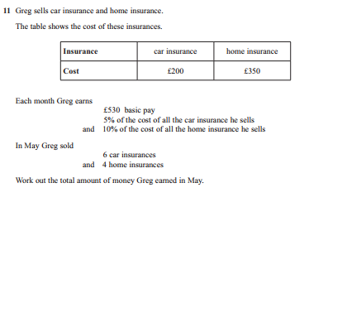
2.

